HO CHI MINH UNIVERSITY OF TECHNOLOGY

**HO CHI MINH UNIVERSITY OF TECHNOLOGY**

Faculty of Computer Science and Engineering

------------------------



Computer Networks

Report for lab 4b

Lecturer: Nguyễn Mạnh Thìn

Student name: Đặng Trần Khánh-1852037

***1/ Are DHCP messages sent over UDP or TCP?***

Answer: DHCP messages are sent over UDP

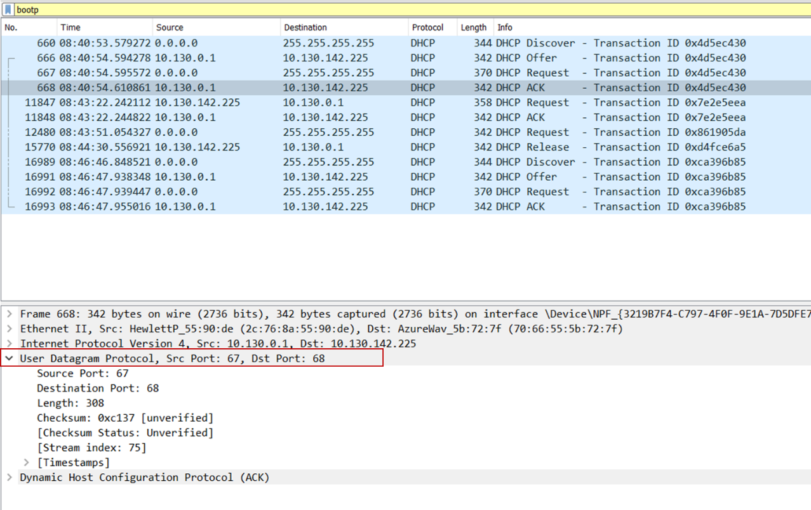

***2/Draw a timing datagram illustrating the sequence of the first four-packet Discover/Offer/Request/ACK DHCP exchange between the client and server. For each packet, indicated the source and destination port numbers. Are the port numbers the same as in the example given in this lab assignment?***

Answer: The Discover packet has source port number 68 and destination port number 67.

The Offer packet has source port number 67 and destination port number 68.

The Request packet has source port number 68 and destination port number 67.

The ACK packet has source port number 67 and destination port number 68.

It is the same as in the given lab assignment example.

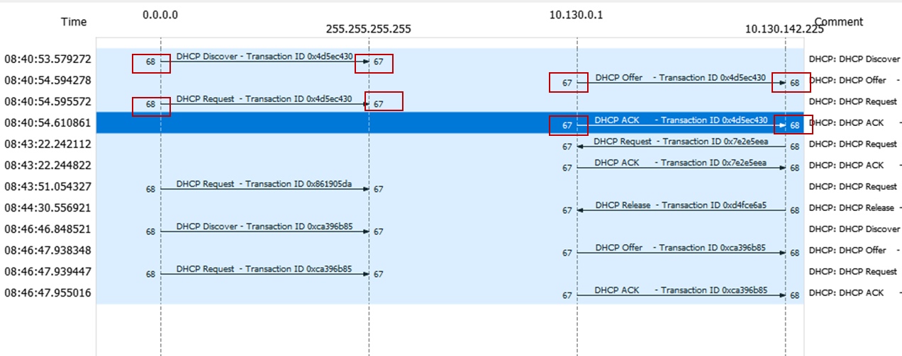

***3/ What is the link-layer (e.g., Ethernet) address of your host?***

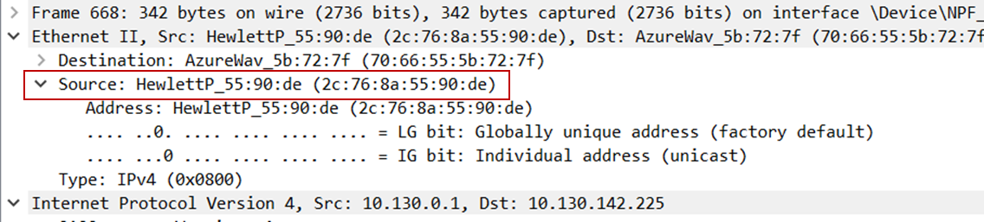Answer: The link-layer address my host is (2c:76:8a:55:90:de)

***4/ What values in the DHCP discover message differentiate this message from the DHCP request message?***

Answer: The DHCP Message Type of DHCP discover message is ‘Discover’, while

the message type of DHCP request message is request. DHCP request message also includes a DHCP server identifier field.

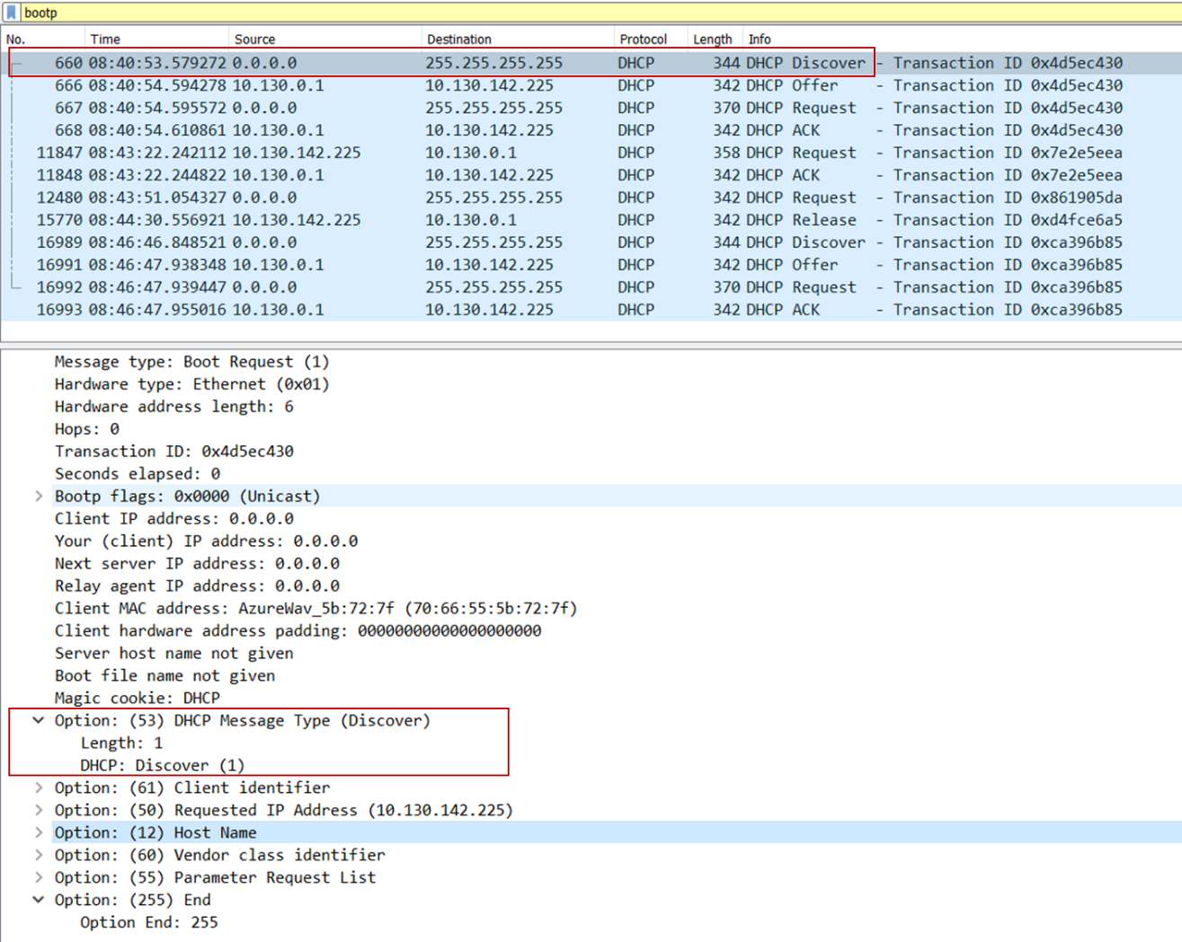

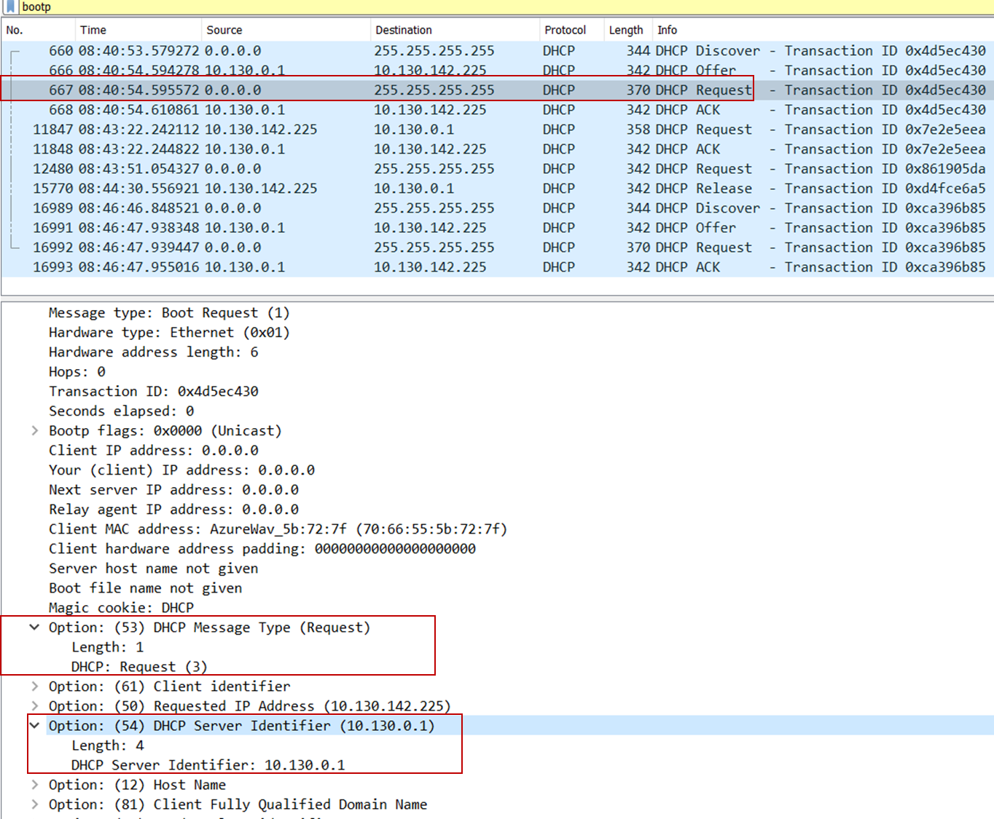

***5/ What is the value of the Transaction-ID in each of the first four (Discover/Offer/Request/ACK) DHCP messages? What are the values of the Transaction-ID in the second set (Request/ACK) set of DHCP messages? What is the purpose of the Transaction-ID field?***

Answer:

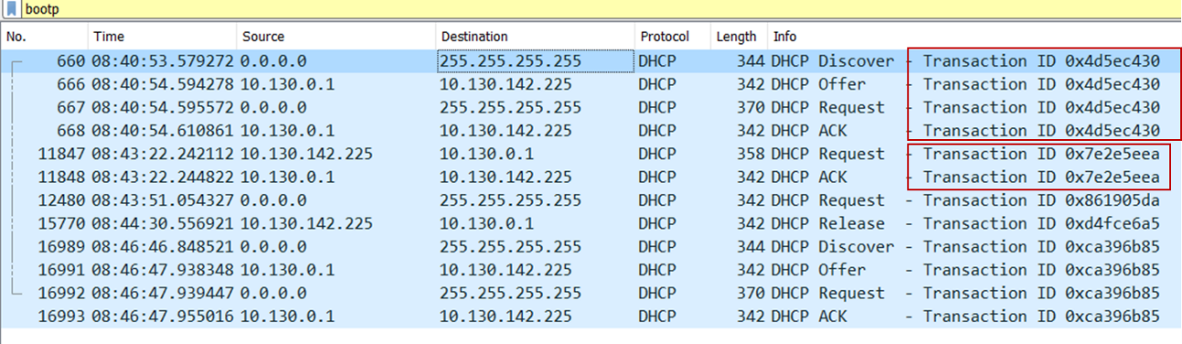The first four DHCP messages’ Transaction-ID is 0x4d5ec430. The second set’ Transaction-ID is 07e2e5eea. The Transaction-ID field. The transaction ID is different so that the host can differentiate between different requests made by the user.

***6/ For each of the four DHCP messages (Discover/Offer/Request/ACK DHCP), indicate the source and destination IP addresses that are carried in the encapsulating IP datagram.***

Answer:

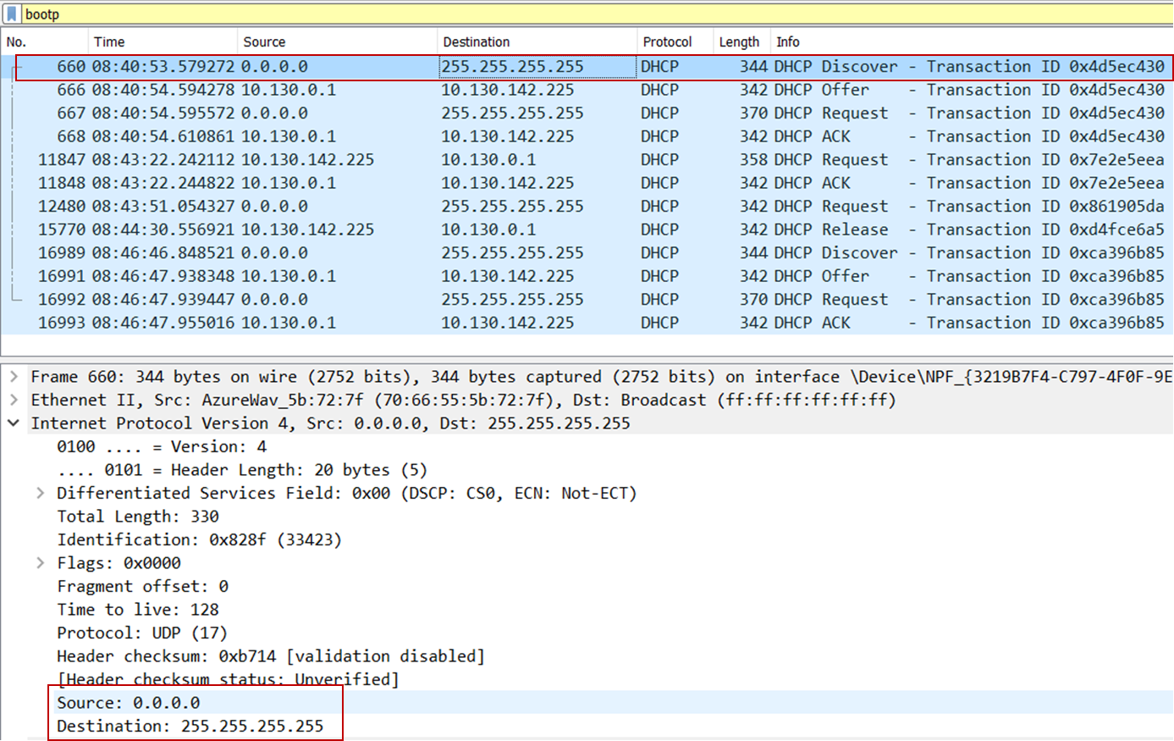Discover message: IP source address is 0.0.0.0, IP destination address is 255.255.255.255

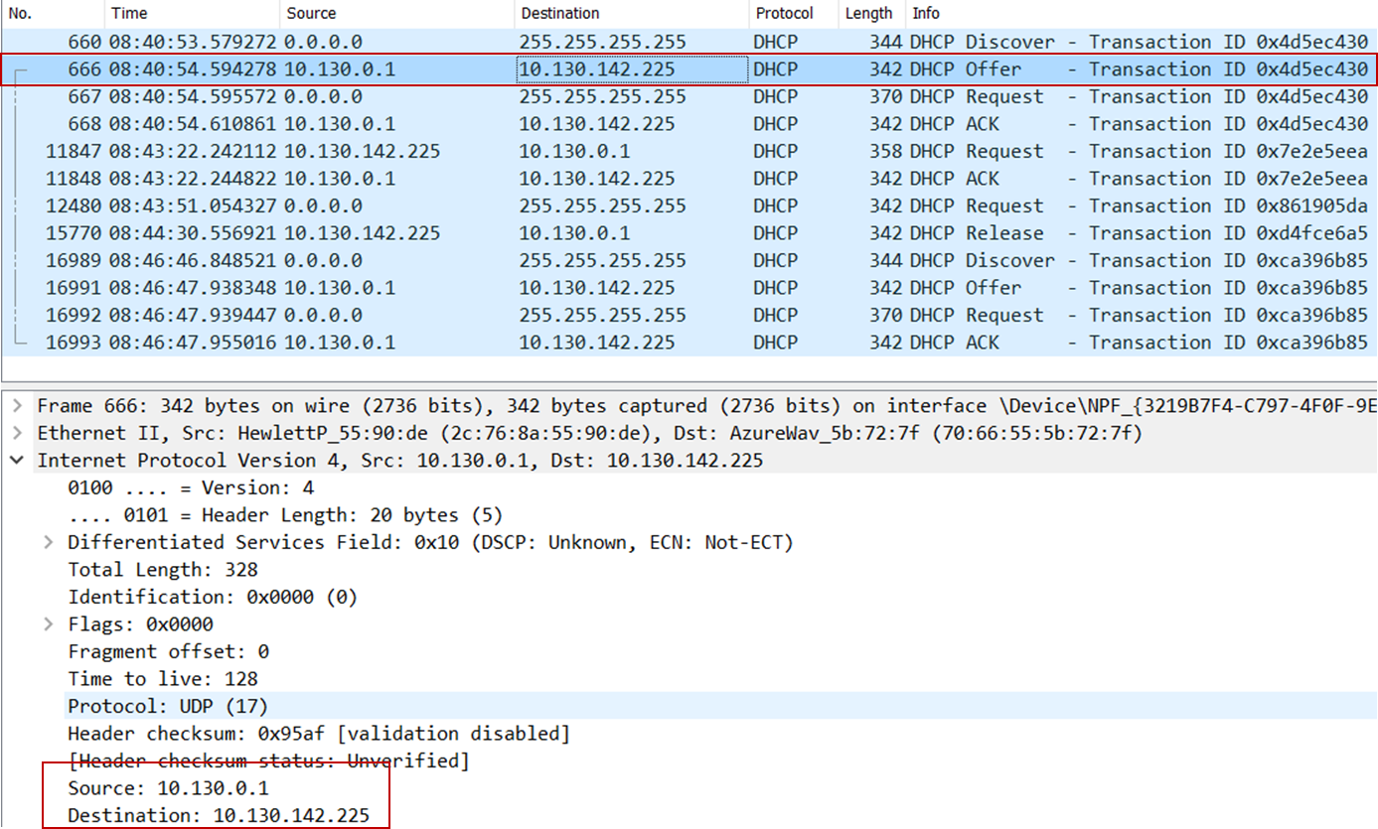Offer message: IP source address is 10.130.0.1, IP destination address is 10.130.142.225

Request message: IP source address is 0.0.0.0, IP destination address is 255.255.255.255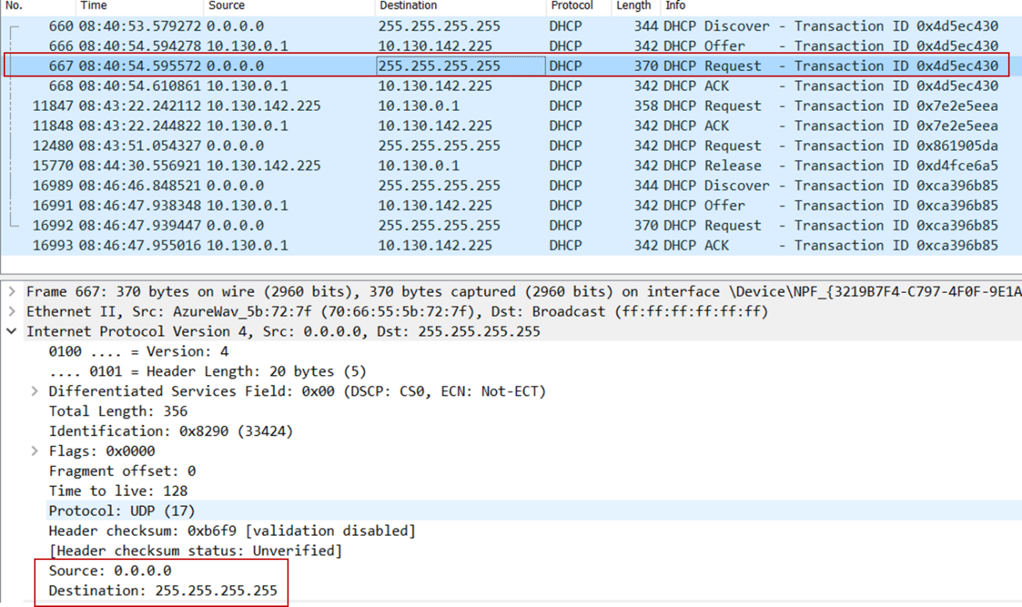

ACK message: IP source address is 10.130.0.1, IP destination address is 10.130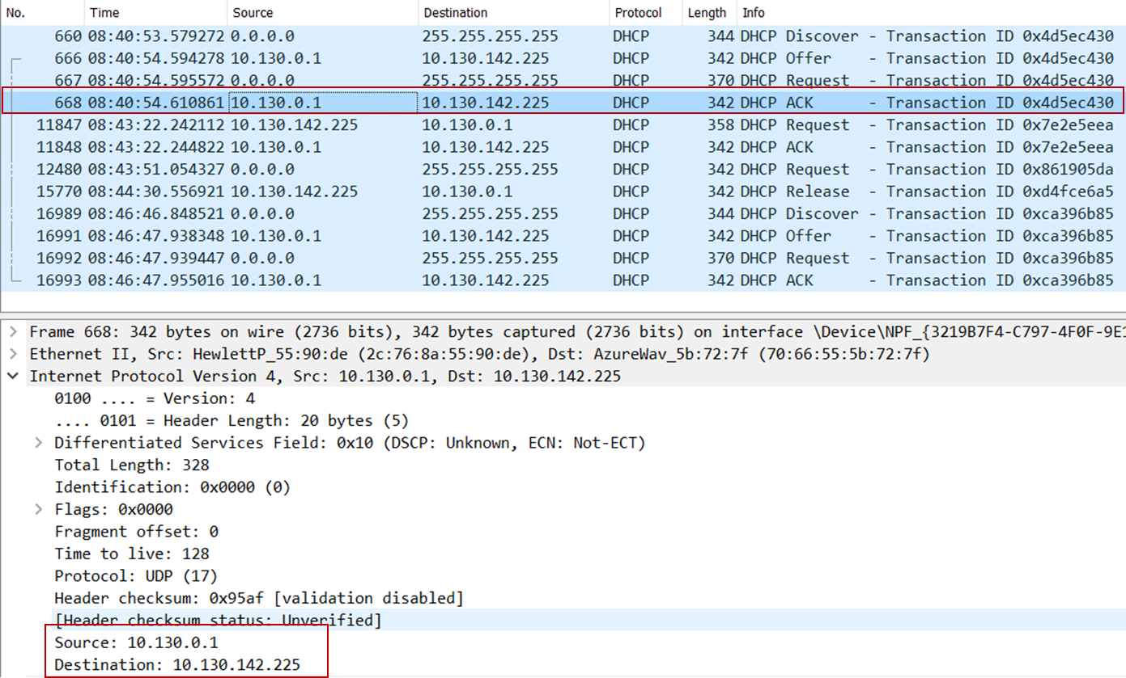.142.225

***7/ What is the IP address of your DHCP server?***

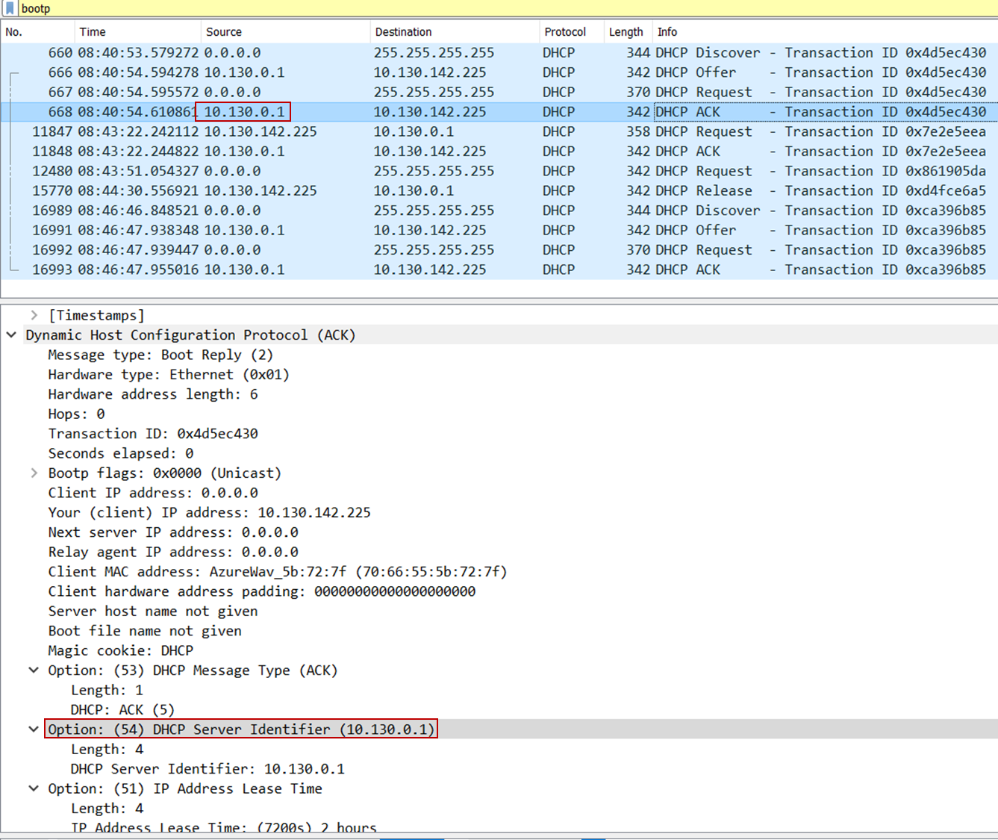Answer: The IP address of my DHCP server is 10.130.0.1

***8/ What IP address is the DHCP server offering to your host in the DHCP Offer message? Indicate which DHCP message contains the offered DHCP address.***

Answer: The IP address the DHCP server offering to my host is 10.130.142.225. The DHCP message type indicates the DHCP message contains the offered DHCP address.

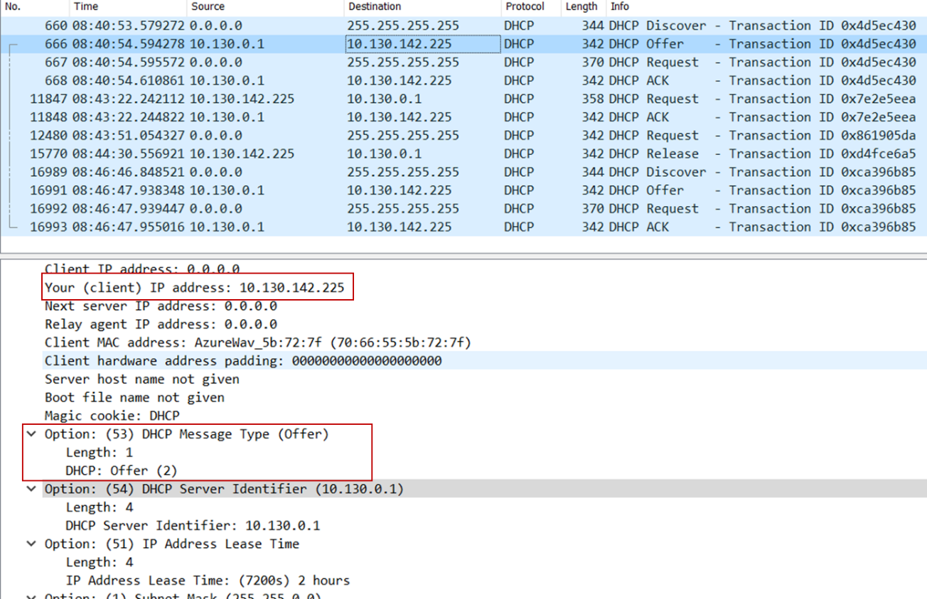

***9/ What values in the trace indicate the absence of a relay agent? Is there a relay agent in your experiment? If so what is the IP address of the agent?***

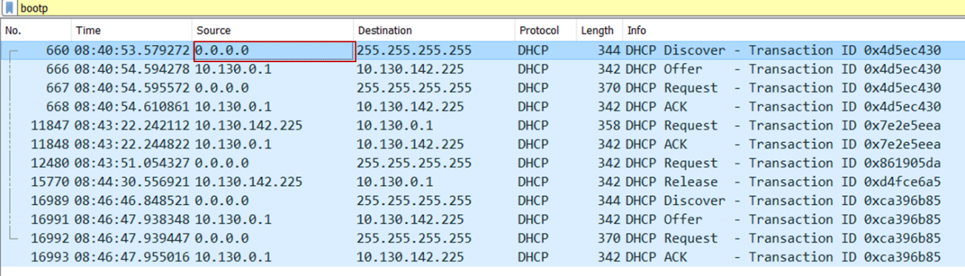Answer: Since the IP is 0.0.0.0 there is no relay agent. If there were an IP there then we could give values in the trace.

***10/ Explain the purpose of the router and subnet mask lines in the DHCP offer message***

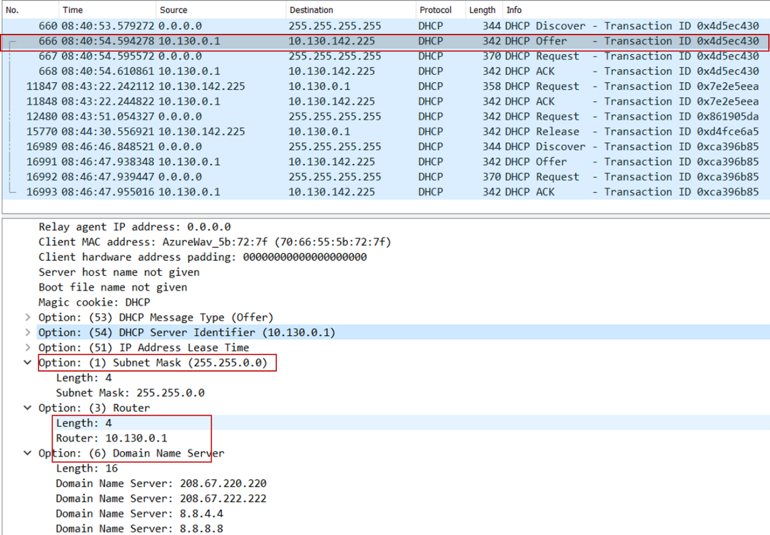Answer: The subnet mask line tells the client which subnet mask it should use. The router line indicates to the client what its default gateway should be.

***11/ In the client’s response to the first server OFFER message, does the client accept this IP address? Where in the client’s RESPONSE is the client’s requested address?***

Answer: The client accepts this IP address, indicated by the requested IP address in the RESPONSE message which is offered in the OFFER message.

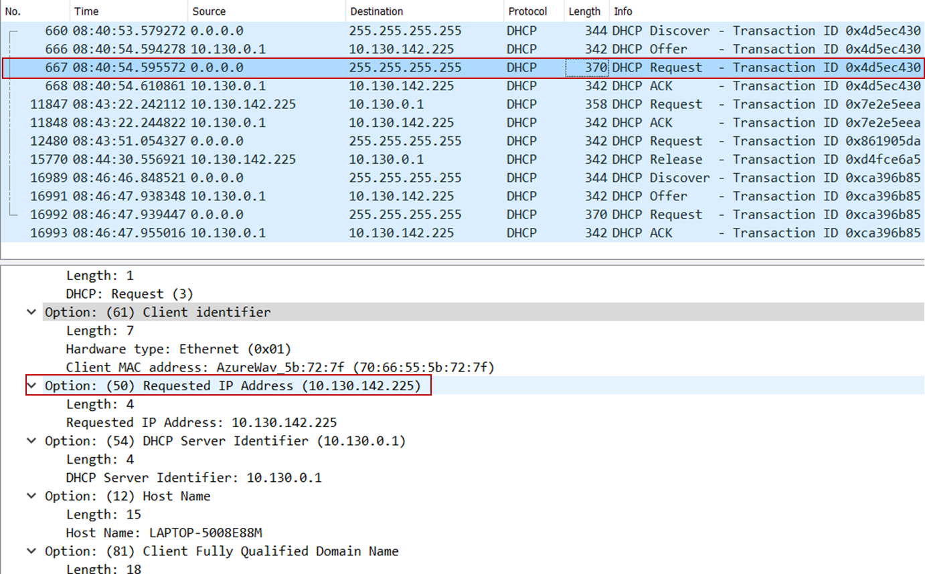

***12/ Explain the purpose of the lease time. How long is the lease time in your experiment?***

Answer: The lease time is the amount of time the DHCP server assigns an IP address to a client. During the lease time, the DHCP server will not assign the IP given to the client to another client, unless it is released by the client. Once the lease time has expired, the IP address can be reused by the DHCP server to give to another client.

In my experiment, the lease time is 1 hour, 57 minutes, 32 seconds.

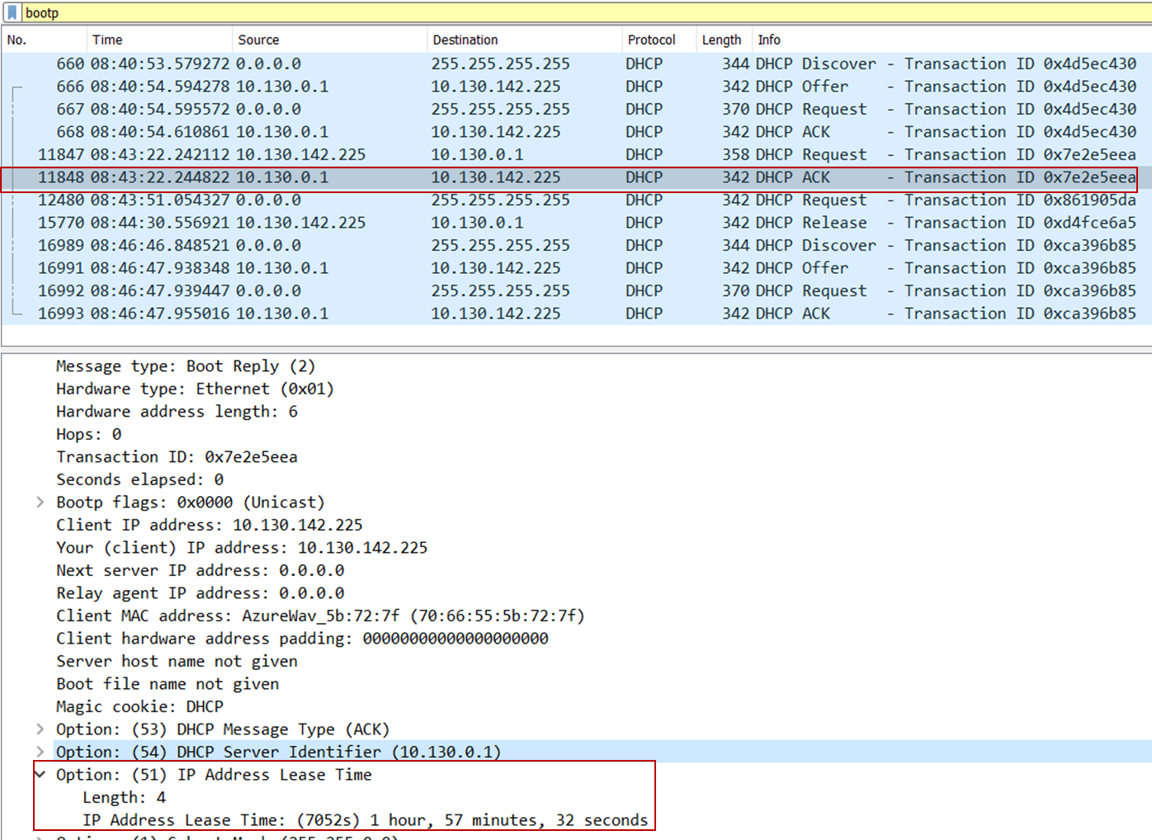

***13/ What is the purpose of the DHCP release message? Does the DHCP server issue an acknowledgment of receipt of the client’s DHCP request? What would happen if the client’s DHCP release message is lost?***

Answer: The client sends a DHCP Release message to cancel its lease on the IP address given to it by the DHCP server. The DHCP server will not issue an ack of receipt of the client’s DHCP request. If the release message is lost then the DHCP server retains the IP address until the lease time expires.

***14/ Clear the bootp filter from your Wireshark window. Were any ARP packets sent or received during the DHCP packet-exchange period? If so, explain the purpose of those ARP packets.***

Answer: There were ARP packets received. The purpose of these packets is to map the MAC address with the IP address.

